

Full STEAM Ahead:
Connecting Library of Congress Primary Sources and Graphic Novels

Lesson Plan Template
Author(s):
Tammy Gaskins & Shannon Griffin
Grade Level(s): 11th
Subject: United States History
Length of Class: Three - 90 minute class periods
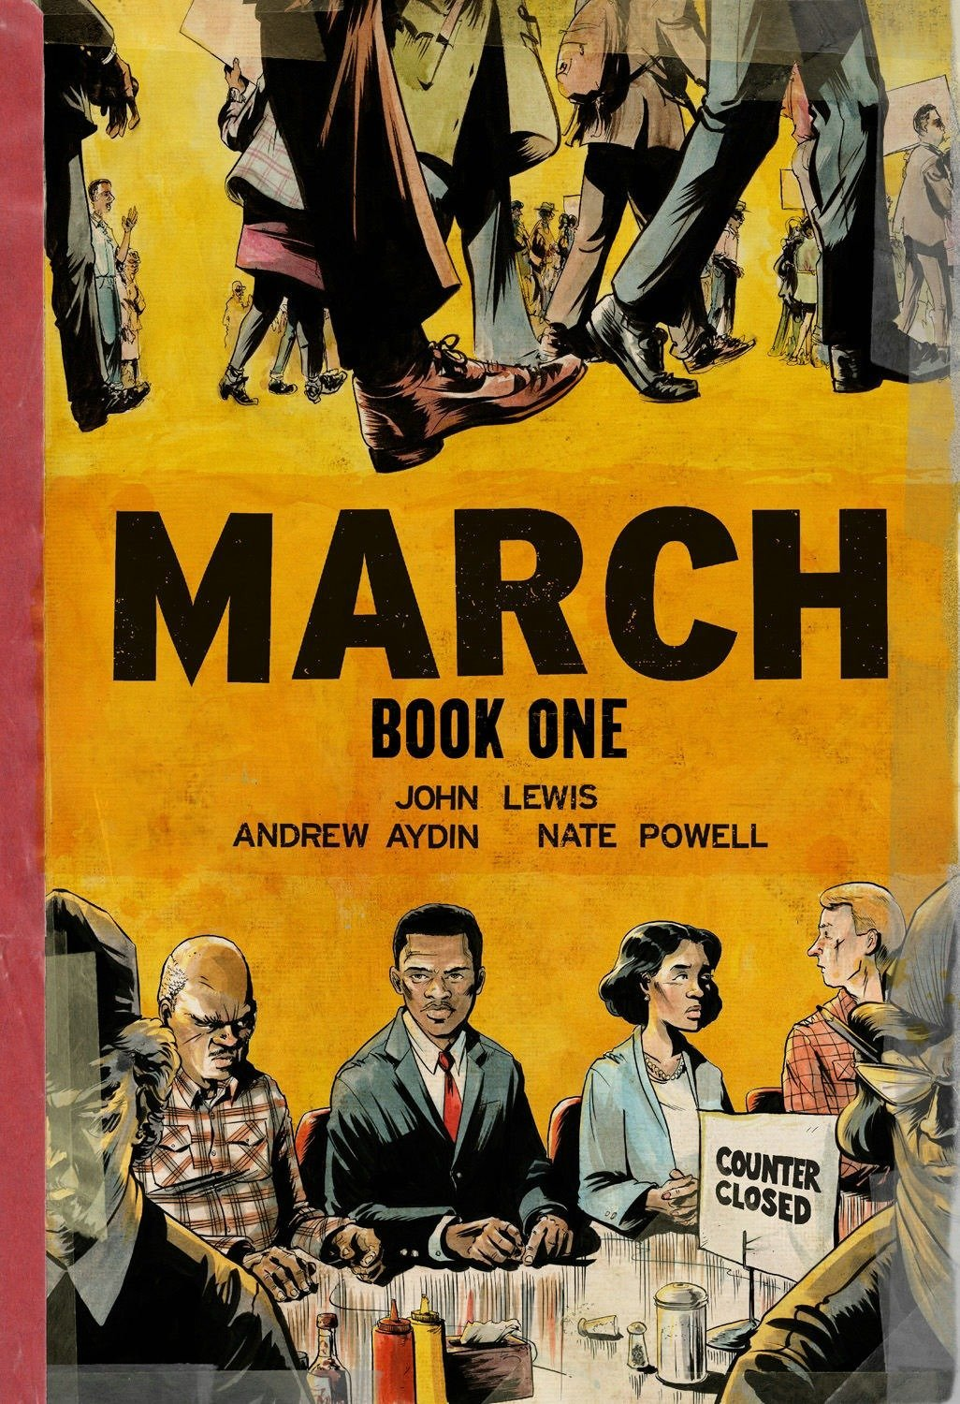

Image Citation:

Powell, N. (2013). March: Book One Book cover [Online image]. In Amazon. https://images-na.ssl-images-amazon.com/images/I/81tM8xMJNjL.jpg

Lesson Title: | The Civil Rights Movement through the Eyes of John Lewis
Overview: | The Civil Rights Movement was organized by Black Americans to end racial discrimination and give equal rights to Black Americans. The movement began in the late 1940s and ended in the late 1960s.  In this lesson, students will research four major events of the Civil Rights Movement through the eyes of John Lewis using the graphic novel “March”, documents from the Library of Congress, and credible educational websites.
Learning Objective: | Identify and interpret primary source documents within a historical context.
Standards: | USHC.5.CC Evaluate continuities and changes during the Civil Rights Movement and other subsequent movements for equal rights. This indicator was developed to encourage inquiry into thematic continuities and changes into how marginalized groups sought and won legal rights. Inquiry into the leadership, methods, and outcomes of modern equal rights movements are supported by this indicator.
Essential Question: | Why did Black Americans have to seek and fight for legal rights and what was the impact of the Civil Rights Movement?
Supporting Question(s): | What was it like to live with segregation?  During the Civil Rights Movement, how did Black Americans fight for legal rights?  What changes came about because of the Civil Rights Movement?
Digital Primary and Secondary Sources: | Rotating Stations Primary Source Activity:  Station #1 - John Lewis’ Youth  The Green Book  Traveling during segregation  Station #2 - Martin Luther King, Jr.  John Lewis Interview  Transcript of John Lewis Interview  Montgomery Bus Boycott  Montgomery Bus Boycott newspaper articles  Station #3 - Student Sit-In Woolworth’s Counter  Woolworth Greensboro counter sit in  Station #4 - Sit-ins and March on Nashville City Hall  History of the Sit-ins and March on Nashville City Hall  Information for theSit-ins and March on Nashville City Hall  Video about Sit-ins and March on Nashville City Hall
Required Classroom Materials: | Teacher: Promethean or SMARTBoard, projector, and laptop  Student: Laptops, paper, pencil, and copy of “March”, copy of questions for each station
Classroom Environment: | Room arrangement: The room is set up with the Interactive Board in the front of the classroom. The desk/tables are set up into four groups. This will allow for the groups to move from station to station during the lesson.
Differentiation and Adaptations: | Collaborative Learning - The teacher will form mixed-ability groups of students to give high achievers a platform to vocalize their ideas, and lower ability students a way of collaborating with and learning from their peers.  Digital Resources - By using interactive tools and digital applications, mixed-ability classes get the opportunity to approach a topic or subject from different angles. This method of differentiation allows different materials, platforms and tools to be used to bring about the same learning outcome and give pupils confidence in their digital skills.

Lesson Sequence/Procedures
Estimated  Time Needed  90 Minutes | Detailed Description of Teaching and Learning  - What clues can you uncover about the life of John Lewis? Your group will rotate around the room to examine and discuss various primary sources that provide information regarding The Civil Rights Movement.  Station #1 - John Lewis’ Youth  - After reading March: Book One, how do you think John Lewis’ life would be different without the influence of his Uncle Otis Carter?  - What difficulties did African Americans face while traveling in the USA?  - Who created the Green book and why?  - What is the importance of the Green Book?  - How was it distributed?
Station #2 - Martin Luther King, Jr.
- Why did he pick Martin Luther King, Jr. as his role model?
- After listening to the interview with John Lewis, how did Lewis say Martin Luther King, Jr. used his sermons to help support the Civil Rights Movement?
- What influenced Americans to identify with Martin Luther King, Jr.?
- Why was the Montgomery bus boycott important?
- What were the three demands of the Montgomery bus boycott?
- How successful was the Montgomery bus boycott?
Station #3 - Student Sit-in Woolworth’s Counter
- What was the goal of the Woolworth’s Counter sit-in in Greensboro, NC?
- Who was involved in the sit-in?
- How long did the sit-in last?
- What was the impact on the United States after the Woolworth’s Counter sit-in?
- What committee was founded from the sit-in movement?
Station #4 - Sit-in and March on Nashville City Hall
- What were the Nashville sit-ins?
- How long did the Nashville sit-ins last?
- What caused the March on the Nashville City Hall?
- Did the March on the Nashville City Hall have any lasting effects?

Assessments: | Informal assessment: Rewatch the video viewed in Station 4; If you were a reporter, what questions would you ask? Make sure students note the person whom they are interviewing.  Have students devise 4-5 questions, and have the students exchange the questions once completed. The student will then answer the questions of the reporter.  Formal assessment: A 20 question multiple choice quiz on March: Book One.
Learning Extensions: | Create a timeline of main events from March: Book One from 1940-1960.  Research events related to the Ruby Bridges school event and list the events leading up, during, and after her going to a white school for a year.

