Full STEAM Ahead:
Connecting Library of Congress Primary Sources and Graphic Novels

Lesson Plan Template
Author(s):

Jessica Colella-Shake and Matthew Fenech
Grade Level(s):

6th-8th
Subject:

Social Studies
Length of Class:

60 minutes

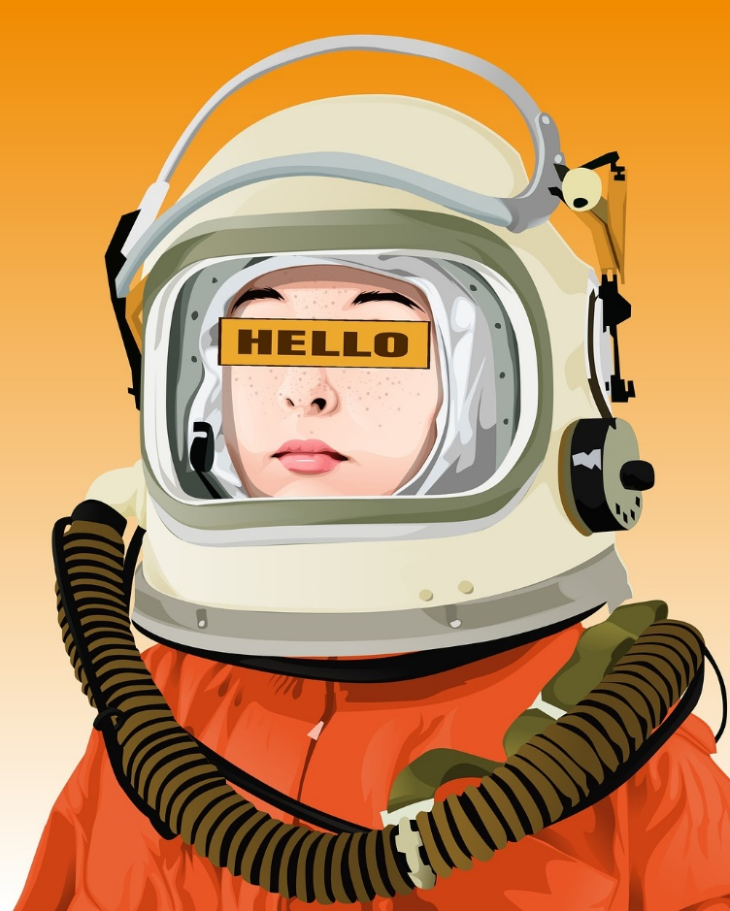
Image Citation:

https://pixabay.com/illustrations/astronaut-space-suit-woman-girl-6195007/
Lesson Title: | Astronauts & Discus
Overview: | Students will utilize Discus to find primary sources to help craft a biography about a subject discussed or mentioned in the graphic novel Astronauts.
Learning Objective: | - Students will gain a better understanding of what a “primary source” is.  - Students will feel comfortable navigating Discus to locate potential primary sources.  - Students will hone their informative writing skills while crafting a short biography.
Standards: | To demonstrate their ability to use evidence in the study of history, students should:  ● compare various types of sources to be used in a South Carolina Social Studies College- and Career-Ready Standards Page 76 Indicator  Expression: primary and secondary sources, used in an inquirybased study of history.  ● engage in historical thinking skills to collect evidence from various sources that identifies bias, context, tone, purpose, and periodization.  ● evaluate secondary sources for accuracy and validity.  ● examine multiple points of view to construct a historical argument.  ● corroborate multiple sources  See also:  W (2.1)  I (3.1-3.4)
Essential Question: | How can you utilize Discus sites to find accurate and reliable primary and secondary sources?
Supporting Question(s): | What is a primary source?  What is a secondary source?  How do I conduct responsible and accurate research practices?  How can I organize and present my research in a format that accurately conveys my findings to others.
Digital Primary and Secondary Sources: | Primary sources will vary depending on what students search and gather while utilizing Discus.  Secondary sources:  https://scdiscus.org/  https://go.gale.com/ps/start.do?p=BIC&u=scschools  https://research.ebsco.com/c/rc7cez/
Required Classroom Materials: | Student Chromebook/devices (1:1)  A promethean board/smart board for displaying accompanying slides, websites, and information.
Classroom Environment: | Students would either work individually or in small groups to research and compile usable information from a variety of primary and secondary sources. Group students by interests/people they are researching.  Make sure a promethean or some kind of interactive bulletin board is visible for students for guidance/instructions and hands on practice navigating Discus as needed.
Differentiation and Adaptations: | To differentiate for learners, make sure to provide small group work when necessary.  For ESOL learners, translation can be utilized on different webpages to assist with research.

Lesson Sequence/Procedures
Estimated  Time Needed | Detailed Description of Teaching and Learning
5 Minutes | Grouping, seating, agenda framework
15 Minutes | Discuss primary versus secondary sources. Use predetermined resources from Discus and quiz students on whether they would label the source as primary or secondary. Utilize movement for this activity (ex: “primary” stand on this half of the room and “secondary” stand on this half). Have students provide reasoning for their choices.
20 minutes | In detail, go over the different aspects of Discus research-specifically utilizing Gale Biography in Context and Ebsco to highlight important Discus features.
20 minutes | Students research individually or in small groups while utilizing Discus to find reliable primary and secondary sources.
(Additional blocks/future time as needed) | If students are to create a brief biography in class (one page, three paragraphs consisting of introduction to person/general overview of their life, body consisting of achievements/why they are famous, conclusion stating end of life/current happenings in their life and long-lasting effects on society), set aside additional blocks/time as needed to complete research and biography assignment.

Assessments: | Informal evaluations could consist of monitoring research and asking students to specifically label their primary versus secondary sources for feedback.  Another informal option, especially within small groups, could be a peer review based off of a premade scoring rubric.  Formal assessments could include a final grade for the final biography product that is produced and turned in.  An additional exit slip could be a survey utilized to collect student feedback in regards to the assignment.
Learning Extensions: | Learning extensions could be created by close-reading other nonfiction or historical fiction or memoir graphic novels that could be analyzed and researched utilizing primary or secondary sources.  Examples:  American Born Chinese  El Deafo  Laika  Maus  Hazardous Tales series  History Comics series  Big Ideas series  Science Comics series  Around the World  Primates  When Stars are Scattered

