Full STEAM Ahead:
Connecting Library of Congress Primary Sources and Graphic Novels

Lesson Plan
Author(s):
Alicia Dixon, Lead Teacher
Debbie Gramling, Media Specialist
Grade Level(s):
9th grade
Subject:
English
Length of Class:
90 minutes

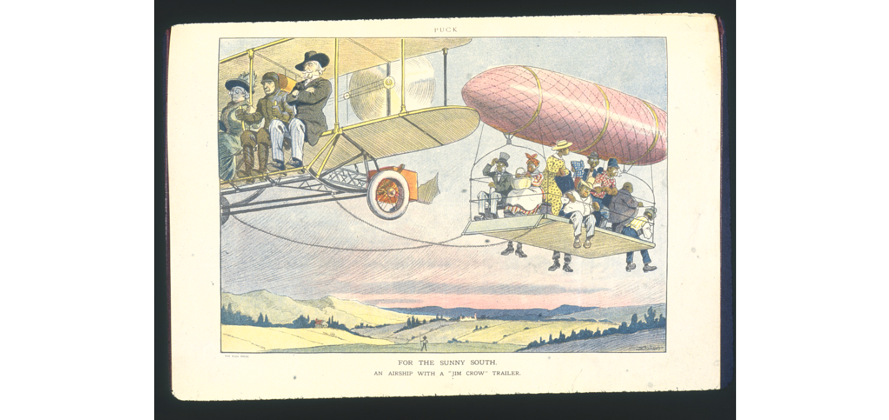
Image Citation:
https://www.loc.gov/static/classroom-materials/jim-crow-segregation/documents/airshiptrailer.pdf

Lesson Title: | Filtered Perceptions: Examining the Jim Crow Era and the Civil Rights Movement through Different Perspectives
Overview: | Students will identify the themes and difference in point of views in multiple ethnicities during the Jim Crow era in the south.
Learning Objective: | Students will: 1) Demonstrate an understanding that the point of view is determined by the author. 2) Demonstrate that a different point of view exists. 3) Demonstrate an understanding that people have different points of view.
Standards: | RI Standard 10: Analyze and provide evidence of how the author’s choice of purpose and perspective shapes content, meaning, and style. 10.1 Determine an author’s point of view or purpose in a text and analyze how an author uses rhetoric to advance that point of view or purpose
Essential Question: | How does the narrator’s point of view affect the events in the narrative?
Supporting Question(s): | What is point of view?  Who is the narrator in the story?  How does society influence our identity and the choices we make?
Digital Primary and Secondary Sources: | - Background Information (given to review prior to lesson):  - American Civil Rights Movement  https://www.britannica.com/event/American-civil-rights-movement  - Civil Rights Movement: Timeline, Key Events, and Leaders  https://www.history.com/topics/civil-rights-movement  - Graphic Novels (read and discussed in class prior to lesson):  - March by John Lewis and Andrew Aydin  https://www.penguinrandomhouse.com/series/1MA/march  - To Kill a Mockingbird by Harper Lee  https://www.harpercollins.com/products/to-kill-a-mockingbird-a-graphic-novel-harper-leefred-fordham?variant=33007291498530  - Manuscripts:  Civil Rights Act Exhibition, Library of Congress  https://www.loc.gov/exhibits/civil-rights-act/index.html  James Forman, Executive Secretary, Student Nonviolent Coordinating Committee. [Report on the march from Selma to Montgomery], Alabama, March 7, 1965. Typescript. Page 2 - Page 3 - Page 4 - Page 5 - Page 6. James Forman Papers, Manuscript Division, Library of Congress (279.00.00)  https://www.loc.gov/exhibits/civil-rights-act/images/cr0279_enlarge.jpg  - Jo Downs to the Voices of Civil Rights Project, February 2004. Letter. Voices of Civil Rights Project Collection, American Folklife Center, Library of Congress (276.00.00) Courtesy of Randa Jo Downs  https://www.loc.gov/exhibits/civil-rights-act/images/cr0276_enlarge.jpg  - Letter, Eleanor Roosevelt to Walter White detailing the First Lady's lobbying efforts for federal action against lynchings, 19 March. 1936. Manuscript/Mixed Material. www.loc.gov/item/mcc.015/  Letter from a child to the President concerning civil rights issues in Birmingham, Alabama, September 1963  https://catalog.archives.gov/id/193938  - Newspapers:  The chronicle. (Pascagoula, Miss.), 03 Sept. 1963. Chronicling America: Historic American Newspapers. Lib. of Congress. https://chroniclingamerica.loc.gov/lccn/sn87065526/1963-09-03/ed-1/seq-1/  Jackson advocate. [volume] (Jackson, Miss.), 04 Aug. 1962. Chronicling America: Historic American Newspapers. Lib. of Congress. https://chroniclingamerica.loc.gov/lccn/sn79000083/1962-08-04/ed-1/seq-1/  - Photographs:  - Lincoln Memorial Youth March for Integrated Schools  https://catalog.archives.gov/id/175539930  - Wolcott, Marion Post, photographer. Negro going in colored entrance of movie house on Saturday afternoon, Belzoni, Mississippi Delta, Mississippi  www.loc.gov/item/2017754826/  - Political Cartoons in Herblock’s History Exhibition, Library of Congress  https://www.loc.gov/exhibits/herblocks-history/index.html  - "It's all right to seat them. They're not Americans," April 27, 1961. Ink, graphite, and opaque white over graphite underdrawing on layered paper. Published in the Washington Post (48) LC-USZ62-127069  - "Pray keep moving, brother," August 14, 1960. Ink, graphite, and opaque white over graphite underdrawing on layered paper. Published in the Washington Post (46) LC-USZ62-127075  - "Sorry, but you have an incurable skin condition,"July 4, 1963. Ink, graphite, and opaque white over graphite underdrawing on layered paper. Published in the Washington Post (54) LC-USZ62-127084
Required Classroom Materials: | Teacher will need a laptop, promethean board, novel as well as graphic novel, chosen primary sources.  Student will need (provided by teacher) index cards, primary sources analyzation hand out, pencil or pen, highlighter
Classroom Environment: | Desks will be arranged in five stations, each station would have six spaces to allow up to six members per station at a time.
Differentiation and Adaptations: | In each group there will be students who may learn the same way as well as students who share some of the same interests. This was modified to ensure a safe and positive environment throughout this controversial lesson.

Lesson Sequence/Procedures
Estimated  Time Needed | Detailed Description of Teaching and Learning
20 minutes | Students will complete a focus activity analyzing primary sources using newspapers, manuscripts, photographs, and political cartoons from the era. Allotted time will give students an opportunity to visit multiple stations.
15 minutes | Teacher will explain the differences in each item using the observe, reflect and question method (https://www.loc.gov/programs/teachers/getting-started-with-primary-sources/guides/).
25 minutes | Teacher will complete a mini lesson/review on point of view using graphic novels : To Kill a Mockingbird by Harper Lee and MARCH by Adrew Aydin and John Lewis
30 minutes | Students will begin writing a response to Scout’s point of view and how it may differ from that of Tom Robinson’s in To Kill a Mockingbird.

Assessments: | Students will be evaluated informally through their ability to understand and respond to the focus activity. By completing and understanding the activity, students demonstrate their ability to differentiate the various points of views. By having students complete the activity they are providing self feedback.
Learning Extensions: | In addition, there would be a collaboration with the geography teacher to discuss the southern region and where Jim Crow laws were accepted to give students a better understanding of what is considered the south.

