Full STEAM Ahead:
Connecting Library of Congress Primary Sources and Graphic Novels

Lesson Plan Template
Author(s): Anna Barker and Amber Triffon
Grade Level(s): 8
Subject: Social Studies

Length of Class: Three 60 minute class periods

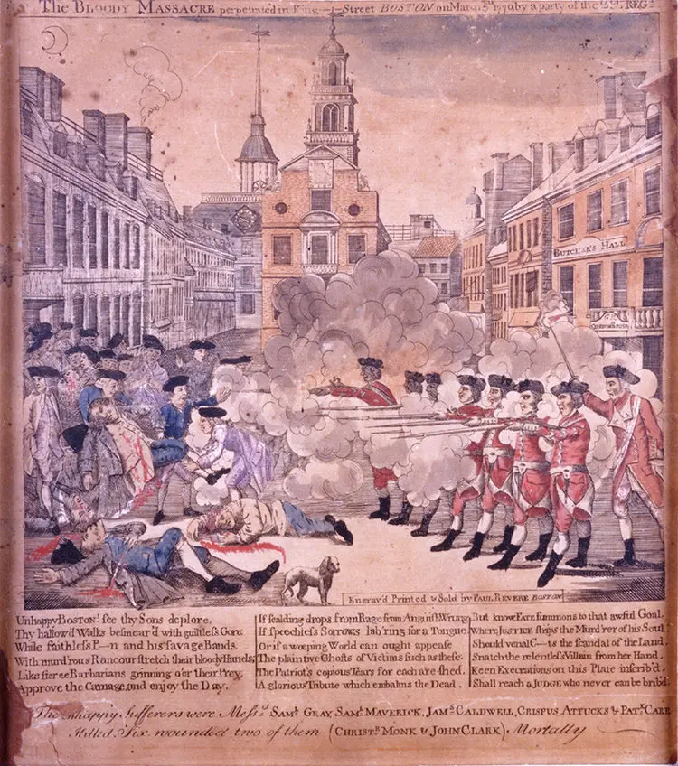
Image Citation:
Paul Revere’s Massacre Print, 1770 [graphic] by P. Revere
[https://revolutionaryspaces.org/the-legacy-of-crispus-attucks-part-i-reinventing-crispus-attucks-for-the-abolitionist-movement/]

Lesson Title: | Using Graphic Novels to Uncover the True Story of the Boston Massacre
Overview: | After learning the elements of graphic novels and evaluating primary sources, students will discover how nonfiction graphic novels contribute to their understanding of primary sources.
Learning Objective: | The student will be able to identify parts of a graphic novel  The student will be able to use primary sources to develop a better understanding of historical events.  The student will be able to compare the primary source to the graphic novel version of the same event.
Standards: | Social Studies  8.2 CO: Compare the motives and demographics of loyalists and patriots within South Carolina and the colonies  8.2 CE Explain the economic, political, and social factors surrounding the American Revolution  8.2 E Utilize a variety of primary and secondary sources to analyze multiple perspectives on the development of democracy in South Carolina and the United States.  AASL Library Standards:  Inquire  A. Learners display curiosity and initiative by:  - Formulating questions about a personal interest or a curricular topic  - Recalling prior or background knowledge as context for new meaning  B. Learners engage with new knowledge by following a process that includes:  - Use evidence to investigate questions.  - Generating products that illustrate learning  C. Learners adapt, communicate, and exchange learning products with others in a cycle that includes:  - Interacting with content presented by others  - Providing constructive feedback  - Acting on feedback to improve  - Sharing products with an authentic audience  Collaborate  - Learners identify collaborative opportunities by  - Deciding to solve problems informed by group  C. Learners work productively with others to solve problems by  - Soliciting and responding to feedback from others  D. Learners actively participate with others in learning situations by:  - Actively contributing to group discussions  - Recognizing learning as a social responsibility
Essential Question: | What are the parts of a graphic novel?  How do nonfiction graphic novels help us understand primary sources?  Who was Crispus Attucks?
Supporting Question(s): | What is the difference between captions and speech bubbles and how do they contribute to the overall message of the story?  What is propaganda?  What was the Boston Massacre?
Digital Primary and Secondary Sources: | Boston Massacre, March 5th 1770 [graphic] by W. Champney  Paul Revere’s Massacre Print, 1770 [graphic] by P. Revere  [https://revolutionaryspaces.org/the-legacy-of-crispus-attucks-part-i-reinventing-crispus-attucks-for-the-abolitionist-movement/]  Hale, Nathan. Hazardous Tales: One Dead Spy. New York: Amulet Books, 2012, pp. 120-127
Required Classroom Materials: | laptop, projector, speakers, markers, chart paper  Students: copy of primary and secondary sources, chromebooks, paper, pencil  Discus: https://school.eb.com/levels/middle/article/Boston-Massacre/317845  https://school.eb.com/levels/middle/article/Crispus-Attucks/316714
Classroom Environment: | The library is arranged with 9 dry erase tables. As students enter, they will be given a number that corresponds to the table. Students can use the table to write any brainstorm ideas or thoughts as they are working.
Differentiation and Adaptations: | Students will be given choice in the final product creation-digital comic strip option OR hand drawn comic strip.  Hands on activities  Collaboration in groups  ML students will be given the option to just illustrate images for final assessment

Lesson Sequence/Procedures
Estimated  Time Needed | Detailed Description of Teaching and Learning
Day 1  60 mins | - Opener: Intro to what a graphic novel is and how to read it  YouTube Video:https://www.youtube.com/watch?v=Xe-FYIqrZrI  Key Vocabulary: display on an anchor chart  frames/panels  gutters  captions  speech/thought bubbles  sound effects  read top to bottom & left to right  Resource: https://www.buffalolib.org/sites/default/files/getgraphic/resources/HowtoReadaGraphicNovel.pdf  - Small groups- students will work as a team to complete a matching activity with graphic novel vocabulary and their definitions.  Matching Cards: https://docs.google.com/document/d/19l0zx3fJjAMOXB_UglSjDyDWk2rqoxYNBtv7WwkLIPQ/edit?usp=sharing  Terms/Definitions:  https://www.readwritethink.org/sites/default/files/resources/lesson_images/lesson1102/terms.pdf  - Small Groups/Partner-Students will analyze graphic novel elements using a graphic novel. (Various graphic novel titles-1 per partnership)  Students will analyze pages of their graphic novel and use sticky notes to annotate pages with graphic novel elements labeling the elements on the sticky note.  Elements needed:  frames/panels  gutters  captions  speech/thought bubbles  sound effects  read top to bottom & left to right  Suggested Graphic Novels: White Bird, Long Way Down, Monster, They Call Us Enemy, March, Smile, Sisters, Percy Jackson series,  - Individual Practice- students will demonstrate their understanding of the graphic novel elements by choosing 2 annotated pages to explain what element is being used and how it impacts the storytelling i.e. captions vs. speech bubbles and sound effects. Choices include: Recording their explanation using Flip (formerly Flipgrid) or finding a different student in the classroom to explain the annotated pages with.
Day 2  60 mins | - Opener: What images and words come to mind when you hear the word “massacre”?  - Small groups- image analysis “Paul Revere’s Boston Massacre” minus the bottom caption. Begin with what do you see, what does it mean, why does it matter? Guiding questions: 1) What two groups are represented in this image? 2) Describe what the crowd is doing and how they are acting. 3) Describe the soldiers’ actions and behaviors. 4)Knowing that Paul Revere was a patriot, what biases might this image show? 5) Does this image depict a massacre? 6) Why might this incident be called “The Boston Massacre”?  - Small groups- image analysis #2 W. Champney’s “The Boston Massacre”. Tell students this is an image of the Boston Massacre from 1850- almost 100 years since the event happened. Guiding questions: 1) What is happening in this picture? 2) How is this image different from Revere’s? What are the differences? 3) Does his image depict a massacre?  - Give students the caption that accompanies the Paul Revere image. In their small groups, students read the caption and discuss what additional information the caption provides [what does it say, what does it mean, why does it matter?].  - Whole group discussion: In which image is Crispus Attucks prominent? Based on the different time periods, why might he be represented differently? What is propaganda? What would Paul Revere create such an image? Why would abolitionists create an alternative image? What changes did they make that would help their cause?  - Exit ticket: In your opinion, do either of the images depict a massacre? Explain your response.
Day 3  60 mins | - Opening: Show the students the image of the Boston massacre used the previous day and have them use the image to explain the event and what they think happened based on the image alone. Have a short discussion to gauge their prior knowledge and assumptions.  - Whole class: students will read and analyze an excerpt of the graphic novel Hazardous Tales: One Dead Spy pp. 120-127 focusing on the excerpt “Crispus Attucks: First to Defy, First do Die!” As students read, they will use the graphic novel elements learned in Day 1 to guide their reading and meaning of the text.  - Small group: After reading the graphic novel excerpt, students will use a graphic organizer (Venn Diagram/Double Bubble) to compare & contrast the information presented in the graphic novel with the primary source image.  - Independent: Students will create a comic strip summary of Crispus Attucks story using graphic novel elements. Students can choose to create a digital version or a hand illustrated one.  Digital Comic Strip Resource: https://www.storyboardthat.com

Assessments: | Informal:  - Matching graphic novel vocabulary with definitions (teacher circulating room during activity and providing immediate feedback with each group)  - Annotation of graphic novel page- gives them practice identifying the elements of a graphic novel in a safe way before being assessed formally  - Flip videos analysis of graphic novel elements (teacher can comment on student videos after viewing)  - Annotation of primary source images (teacher circulating room)  - Compare/Contrast Graphic Organizer  Formal:  Comic Strip Assessment- summary of Crispus Attucks story using graphic novel elements. A rubric will be used to assess students’ knowledge
Learning Extensions: | - Have a selection of additional graphic novels available for students to explore during independent reading time.  - Encourage students to analyze the different parts and discuss their findings with their peers.  - Have students create comic strips to detail other factual stories using other primary source images

