Full STEAM Ahead:
Connecting Library of Congress Primary Sources and Graphic Novels

Lesson Plan Template
Author(s):
Samantha Gentry
Grade Level(s):
10th
Subject:
United States History
Length of Class:
55 minutes

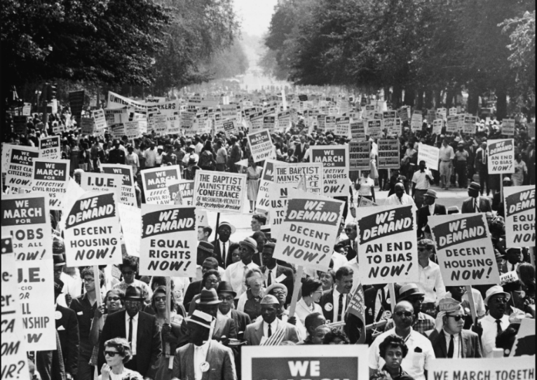
Image Citation:
https://stacker.com/stories/5393/major-civil-rights-moments-every-state

Lesson Title: | Run and the Civil Rights Movement.
Overview: | Students will utilize primary sources and the graphic novel, Run, to analyze the events of the Civil Rights Movement.
Learning Objective: | - Students will evaluate continuities and changes during the Civil Rights Movement by reading the graphic novel Run.  - Students will analyze primary documents to learn about events of the Civil Rights Movement.
Standards: | USHC.5.CC Evaluate continuities and changes during the Civil Rights  Movement and other subsequent movements for equal rights.
Essential Question: | How can I use the “observe, reflect, and question” method to evaluate the events during the Civil Rights Movement?
Supporting Question(s): | - How can I use primary documents to analyze the events of the Civil Rights Movement?  - How can photos provide insight of the events of the Civil Rights Movement?  - How can I relate an informational text to what I am learning in class?
Digital Primary and Secondary Sources: | Primary Sources  - March on Washington for Jobs and Freedom led by march committee with outstretched arms  https://www.loc.gov/item/2013645783/  - Two women sitting on grass near the National Mall during the March on Washington, 1963  https://www.loc.gov/item/2013650622/  - Baltimore branch NAACP pickets  https://www.loc.gov/item/2005694850/  - Dallas County Sheriff Jim Clark points a billy club and electric prod as he tells Negro voting demonstrators to move from in front of the Dallas Courthouse  https://www.loc.gov/item/2005685854/  - Walking in the rain to register to vote, Rev. Martin Luther King, Jr., right, Ralph Abernethy [sic], center, and Rev. Andrew Young lead group of Negroes from church here on walk to Dallas Co. courthouse  https://www.loc.gov/item/2005685850/  Secondary Sources  - Captions/Descriptions for photos  - ReadWorks Article- John Lewis  https://www.readworks.org/article/John-Lewis/97b31c00-fcb4-4647-82f3-97cd29028d1f#!articleTab:content/
Required Classroom Materials: | - Smartboard or projector  - Paper  - Pencils  - Class copies of Run  - Individual copies of ReadWorks Article- John Lewis
Classroom Environment: | - Students’ desks are arranged in assigned seats with their reading groups. This will save time for when students start meeting with their groups while reading Run.  - Photos will placed on the walls of the room, so students can spread out when visiting the different stations.
Differentiation and Adaptations: | - Differentiation for lesson content and teacher instruction will vary based on class and students’ needs.  - Students will be placed in reading groups based on Lexile Level. Multiple levels (high, on grade-level, and low) will be in each group. Strong readers will be placed with struggling readers to assist when reading.

Lesson Sequence/Procedures
Estimated  Time Needed | Detailed Description of Teaching and Learning
8:50-8:55 | To start off the day’s activities, the teacher will have students complete a Bell Ringer activity. Students will be instructed to list five words or names that they associate with the Civil Rights Movement. Students are expected to list common words and names that are typically most notable about the movement. Ex: MLK Jr., Rosa Parks, Boycotts, Sit-ins, etc. The teacher will then lead a small discussion, asking students what were some of the words they wrote down.
8:55-9:05 | The teacher will then provide instructions for an inquiry-based photograph activity. Students will rotate in pre-assigned groups to different stations and analyze different photographs taken from the Civil Rights Movement. Students will use the “observe, reflect, and question” method to analyze each photograph. Students will analyze five photos in total and have 30 seconds at each station.
9:05-9:15 | The teacher will then facilitate a class discussion about each picture from the five stations. The teacher will show each photograph individually from the Smartboard and will call on volunteers to discuss what they “observed, reflected, and questioned”. After each discussion, the teacher will show the caption of the photo explaining what is actually happening in each photograph.
9:15-9:40 | To transition into the next activity, the teacher will display a photograph of John Lewis on the Smartboard and ask students if they know who this person is. If students raise their hands, the teacher should call on them to hear their answers. The teacher will then provide a quick back-story on John Lewis, and introduce the graphic novel Run. The teacher will explain how it is a nonfiction novel that depicts John Lewis’ life and his participation in the Civil Rights Movement. Students will then be placed in pre-planned reading groups based on varying Lexile levels and will read pages 1-7. Students should not only read the text within the novel, but they should also observe the pictures and the characters’ facial expression. Students may need to be reminded of that, if there they have had little experience with graphic novels before.
Homework | Students will be instructed to read John Lewis by ReadWorks. It is a little below reading levels for high school students, but it is a good introduction to John Lewis and his achievements.

Assessments: | Informal: The teacher will assess the students’ prior knowledge of the Civil Rights Movement by facilitating a class discussion about the Bell Ringer.  Informal: The teacher will assess students’ prior knowledge of the Civil Rights Movement by facilitating a class discussion about the photograph activity.  Informal: Before reading, the teacher will assess students’ prior knowledge of John Lewis by facilitating a class discussion after displaying his photo.  Formal: Upon returning to class the next day, the class will have a short pop-quiz over the contents of pages 1-7 of Run and over the information from the homework.
Learning Extensions: | This lesson is an introductory lesson for a unit on the Civil Rights Movement. In future classes, students will continue to read Run and participate in more in-depth activities and discussions centered on its content.

